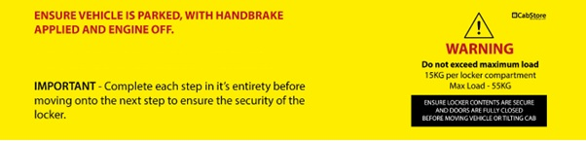
Fitting List
Tools needed:
- Power Drill
- Drill bit 3mm, 6mm, 8mm, 9mm, 11mm
- Hole cutter saw 20mm
- Nut Insert Tool M6 and M8
- Socket/Spanner 10mm, 13mm
- Allan key H4, H5
- Torx key T45
- PH2, PZ2 driver bit/screwdriver
Description | Quantity | Pre-assembled | Fitting kit
M6 x 30mm Flange Head Black (SS) | 19 |  | 19
M6 x 20mm Set | 6 |  | 6
M6 Nylock | 14 |  | 14
M6 x 12mm Washer | 18 |  | 18
M6 x 20mm Washer | 2 |  | 2
M6 Nut Insert | 2 |  | 2
M8 x 30mm Washer black | 6 |  | 6
M8 x 40mm Flange Head Black (SS) | 6 |  | 6
M8 x 30mm Flange Head Black (SS) | 15 |  | 15
M8 Hex Nut Cover Black | 11 |  | 11
M8 Nut insert | 4 |  | 4
M8 Nylock | 11 |  | 11
M8 x 50mm Washer Black | 5 |  | 5
M8 x 25mm Set | 4 |  | 4
M8 x 25mm Washer | 4 |  | 4
M8 Spring Washer | 4 |  | 4
15mm Spacer | 6 |  | 6
M5 x 15mm Domehead | 12 | 12
Wood Screw, Pan head 4.2(no. 8) x 9mm | 4 |  | 4
Wood Screw, Pan head 4.2(no. 8) x 13mm | 12 | 8 | 4
Wood Screw, Pan head 4.2(no. 8) x 25mm | 12 |  | 12
Step 1 – In the rear and both sides of cab walls, remove the 9 plastic bungs (5 rear, 2 driver side and 2 passenger side) marked with red, blue and yellow, in Figure 1.

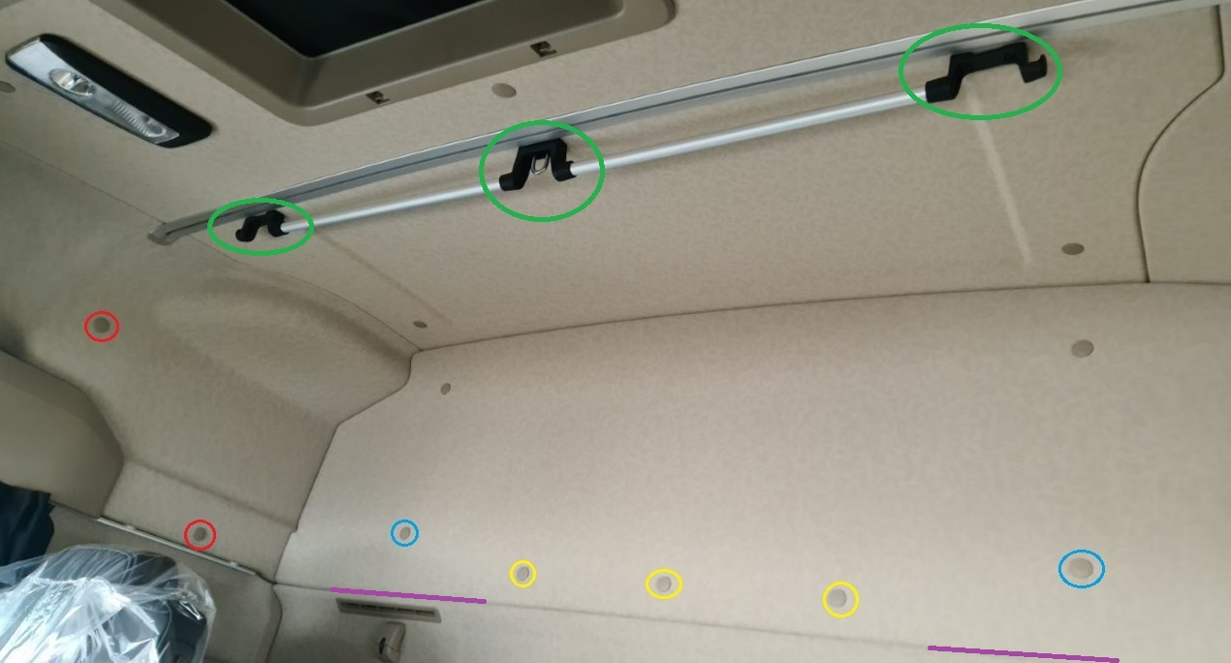
Figure 1

Step 2 – Enlarge the holes just through the upholstery from where the plastic bunks have been removed at “Step 1” to 20mm holes, using hole cutter saw 20mm.
Attention: Use the Power Drill on reverse for start to not damage the upholstery!!! See “Figure 2”.

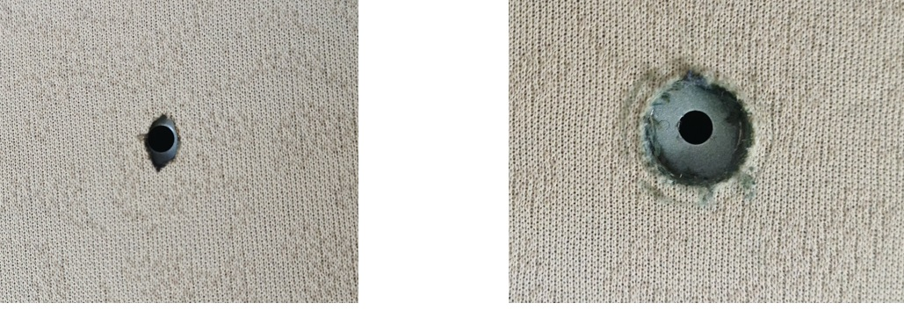
Figure 2
Step 3 – Enlarge the holes in the metal from where the plastic bungs have been removed at “Step 1” red marks to 11mm and blue mark to 9mm from “Figure 1”.
Step 4 – Fit the M8 nut insert into the red marks and M6 nut insert into the blue marks from “Figure 1”.
Step 5 – Remove the factory roof handle marked with green in “Figure 1”, using torx key T45.
Step 6 – Pull the bottom of the interior rear top upholstery panel apart, where the split line is to fit the two rear T brackets under the upholstery and fix it (see “Figure 3” for guidance), using:
- 2 - M8 x 25mm bolt
- 2 – M8 x 25mm Washer
- 2 – M8 Spring Washer
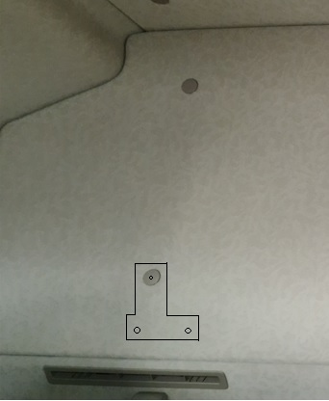
Figure 3
Attention: The top hole 7mm to align with the M6 nut insert fit it at “Step 4”!!! Tight the M8 fixings!

Step 7 – Fit the rear L bar floor bracket, fix it through top holes of the rear T brackets into the M6 nut inserts from “Step 4”, using 2 – M6 x 35 flange head Black. See “Figure 4”.
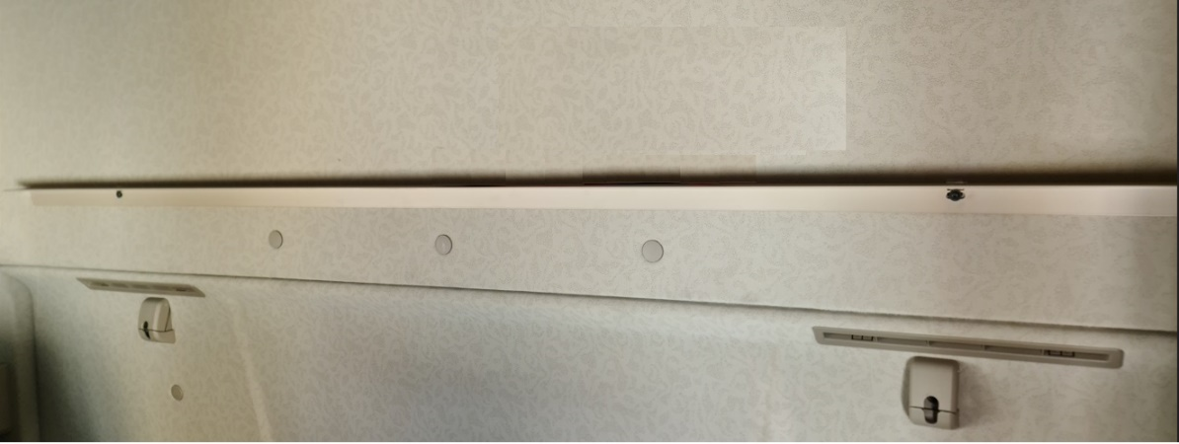
Figure 4
Step 8 – Attach the top brackets to the locker front panel, two small to the sides (blue marks) and big to centre (red mark), see “Figure 5” and “Figure 6”, using M6 x 30 flange head Black. Keep fixings loose but secure! Fit the brackets to the top factory fixing of the roof handle removed at “Step 5”, using 6 – 15mm spacers and 6 – M8 x 40mm flange head black. Keep fixings loose but secure! Tight just the 3 - M6 flat head black first.
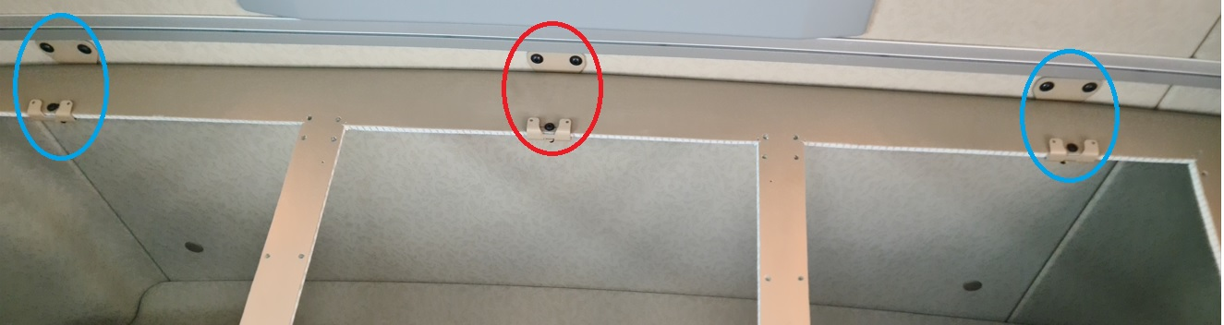
Figure 5
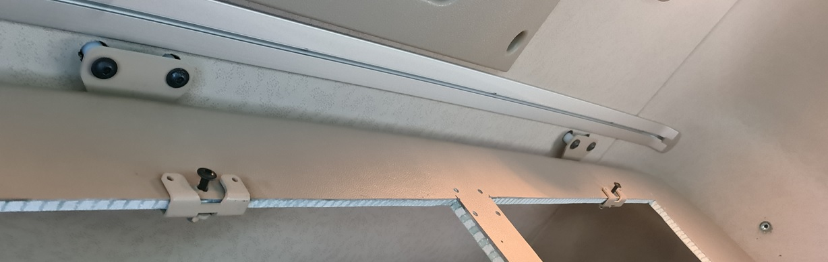
Figure 6

Step 9 – Place the floor panel on top of the rear L bar floor bracket, fitted at “Step 7”, placing the floor panel on top of the bed and lifting the passenger side first. Joint the locker panels together through the predrilled holes, see “Figure 7”, using:
- 6 – M6 x 20mm Bolt
- 12 – M6 x 12mm Washer
- 6 – M6 Nylock.
Tight all fixings inclusively the M8 flange head black from”Step 8”! Cover the joint with the flexible floor cover!
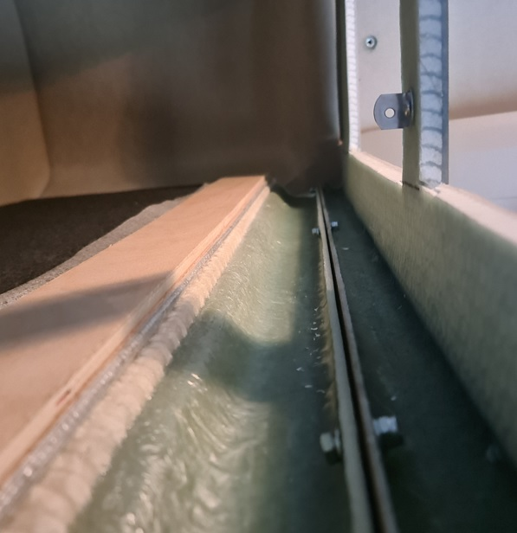
Figure 7

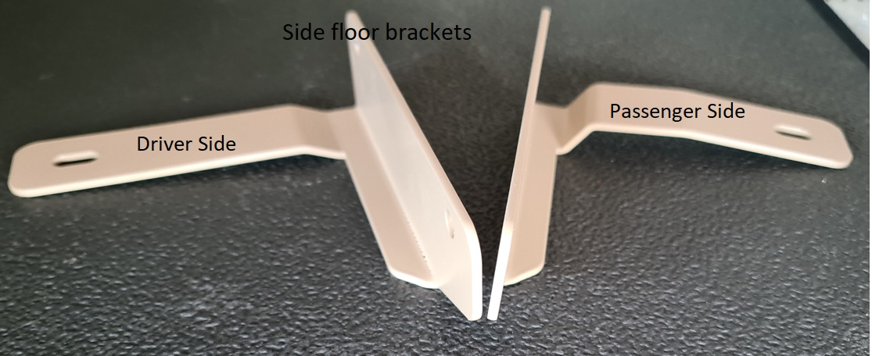
Figure 8
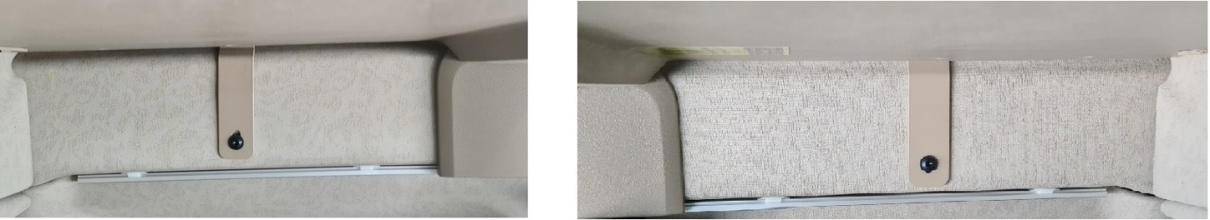
Figure 9

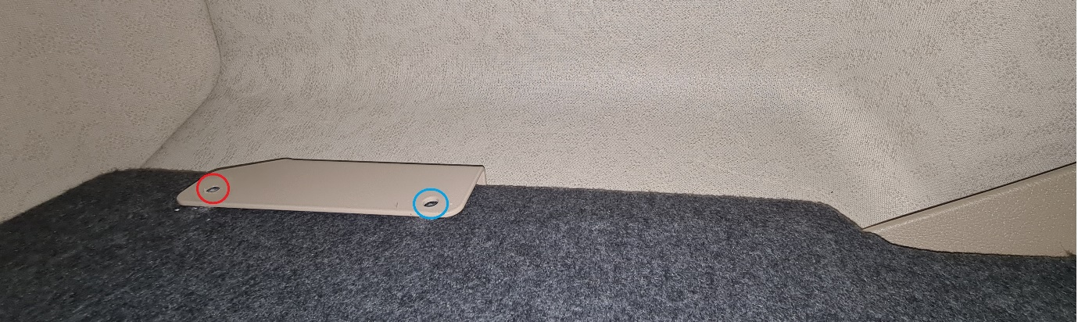
Figure 10

Step 10 – Pass the passenger floor side bracket between side cab wall upholstery and locker floor, lifting the rear side of the locker floor, see “Figure 8”, “Figure 9” and “Figure 10”, from inside the locker, see “Figure 11A” and secure it into the M8 nut insert fitted at “Step 4” (under locker), using M8 x 30mm flange head black.
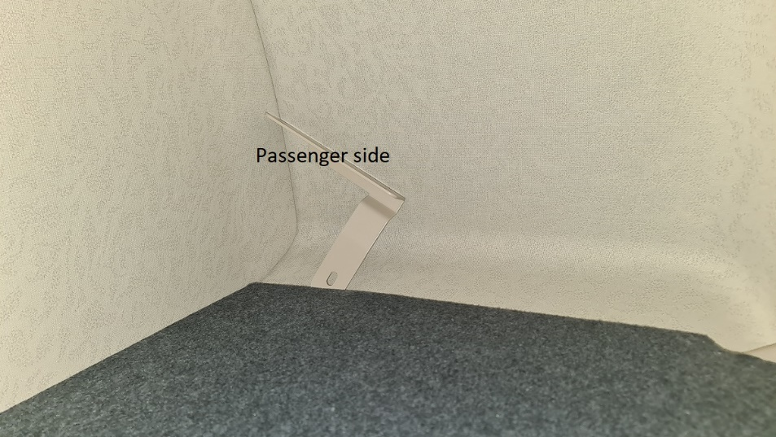
Figure 11A
Pass the driver floor side bracket between side cab wall upholstery and locker floor, see “Figure 8” and “Figure 9”, from under the locker,see “Figure 11B” and fix it into the M8 nut insert fitted at “Step 4”, using M8 x 30mm flange head black.
Keep fixings loose but secure!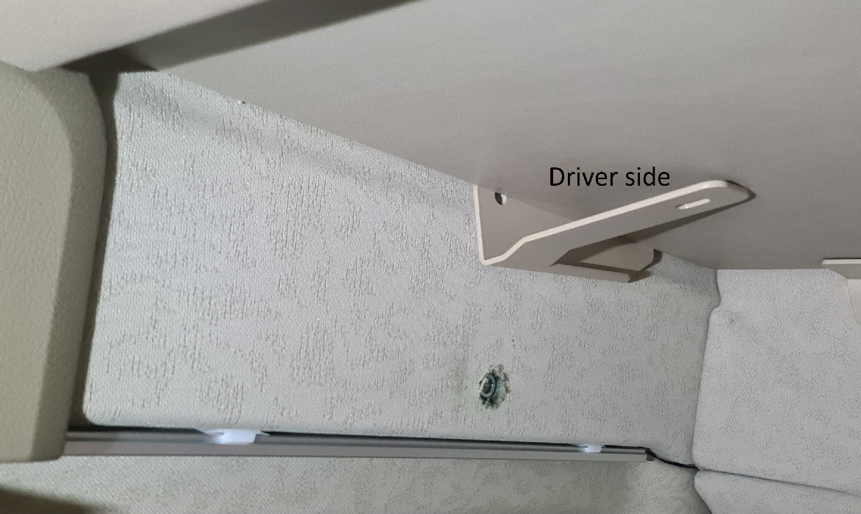
Figure 11B

Step 11 – Pushing the floor against the rear cab wall, from under the locker, drill into the locker floor five 8mm holes through the rear L bar floor bracket fitted at “Step 7”, see “Figure 12”, secure it using:
- 5 – M8 flange head black
- 5 – M8 x 50mm Washer black
- 5 – M8 nylock
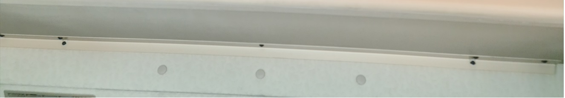
Figure 12

Step 12 – From inside the locker drill the locker floor four 8mm holes through both of the side floor brackets fitted at “Step 10”, see “Figure 10” (blue and red mark), secure the rear fixing (red mark) using:
- M8 flange head black
- M8 x 30mm Washer black
- M8 nylock.

Step 13 – From inside the locker pass the Y brackets between side cab wall upholstery and locker face, see “Figure 13”, secure it into the M8 nut insert fitted at “Step 4” (outside front locker, red mark), using M8 x 30mm flange head black. Keep fixings loose but secure, hand tight all way in!
Secure the Y bracket through the side floor bracket and locker floor (blue mark “Figure 13”), drilled at “Step 12”, using:
- M8 flange head black
- M8 x 30mm Washer black
- M8 nylock
Drill the locker floor through the Y bracket 8mm hole into the forward hole (green mark “Figure 12”), secure it as above!
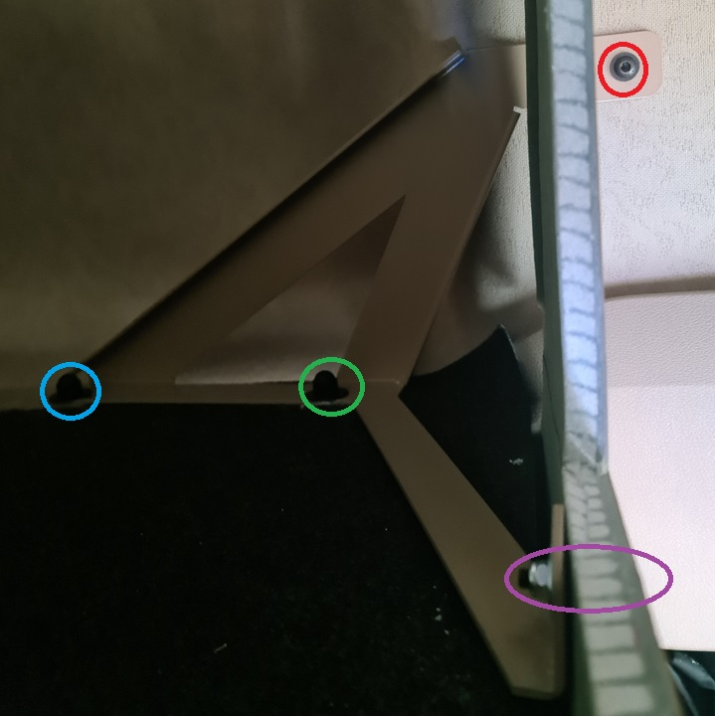
Figure 13

Step 14 – Drill the locker face through the Y bracket 6mm hole (purple mark “Figure 13”), secure it using:
- M6 flange head black
- M6 x 20mm Washer
- M6 nylock
Attention: Tight all fixings!!!
Step 15 – Cover all M8 floor fixing from inside the locker, using M8 nut cover black.

Step 16 – Fit all doors assembly through the predrilled holes, using M6 x 30mm flange head black, see “Figure 14”.
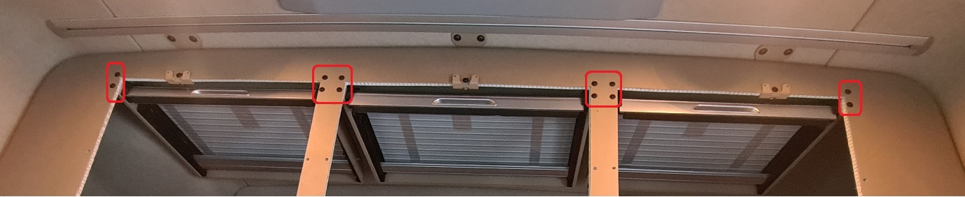
Figure 14
Step 17 – From the side door aperture, insert dividers between door assembly against the L brackets from inside the locker face, secure through the L brackets from centre door aperture secure the divider using 13mm wood screw (see “Figure 15”), then into the floor use 9mm wood screw (see “Figure 16”).
Do not over-tighten!
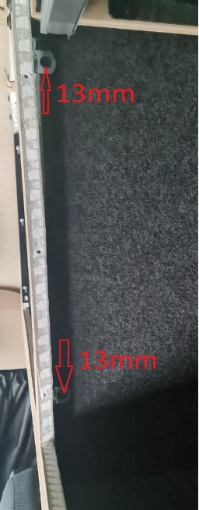
Figure 15
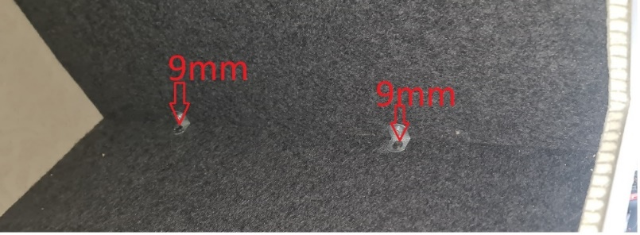
Figure 16

Step 18 – Install the side runners by sliding upwards into the slots of the door assembly, drill 3mm holes and secure with 25mm wood screw, see “Figure 17”.
Do not over-tighten!
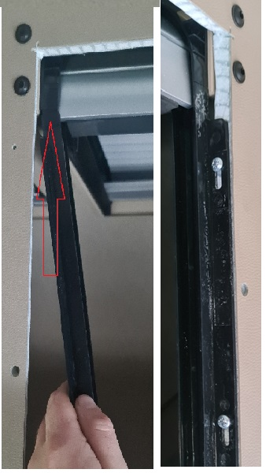
Figure 17
Step 19 – Instal the door surrounds by pushing the surround studs through the predrilled holes in the locker front, secure it using M6 washer and M6 nylock, see “Figure 18”.
Do not over-tighten, tight till the door surround touch the locker face!
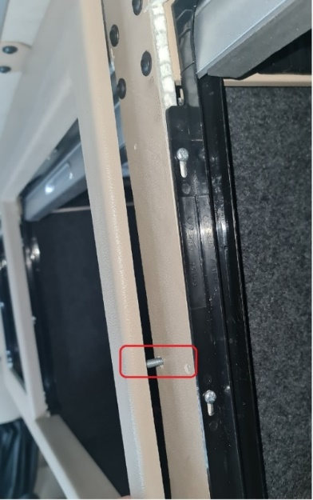
Figure 18
ENSURE ALL FIXINGS ARE TIGHT AND CHECKED PRIOR TO USING VEHICLE!

