Step 1: Fix 4 - Platform “L” shape bracket marked with blue arrow in below Figure 1, using for front brackets:
- 2 – M16 x 40mm set;
- 4 – M16 x 30mm washer;
- 2 – M16 nylock.
And using for rear brackets:
- 2 – M16 x 80mm set;
- 4 – M16 x 30mm washer;
- 2 – M16 nylock.
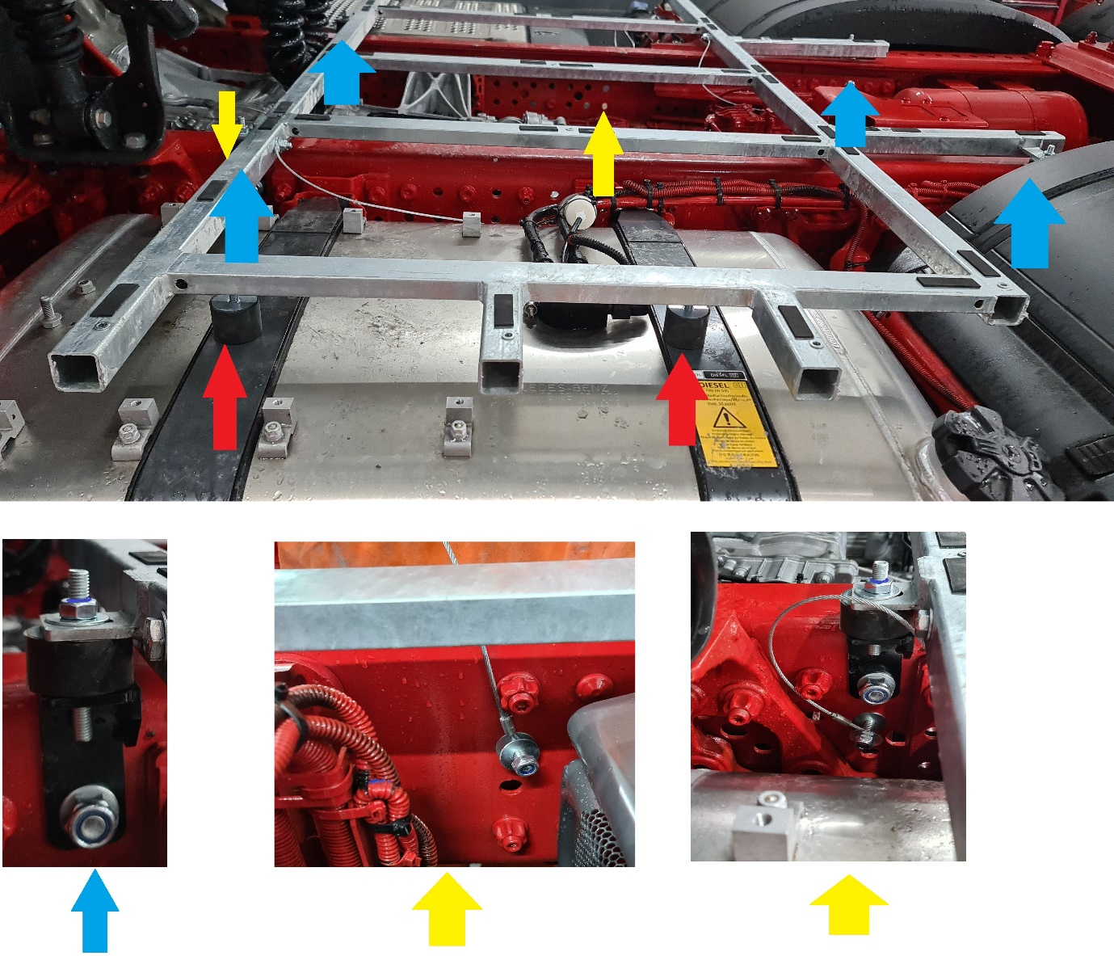
Figure 1

Step 2: Place and fix the frame on the brackets fitted at “Step 1”, using:
- 4 – M10 x 30 washer;
- 4 – M10 nylock.

Step 3: Fix the Safety wire marked with yellow arrows in Figure 1 above, using:
- 2 - M10 x 40mm set;
- 6 – M10 x 30mm washer;
- 2 – M10 nylock.

Step 4: Adjust and lock the M10 Anti Vibration mount single stud marked with red arrow in Figure 1 above.

Attention!!! Check all fixings!

Step 5: Remove the bottom fixing of the factory fitted handle, marked with a red arrow in the Figure 2 bellow and pull it to passenger side!
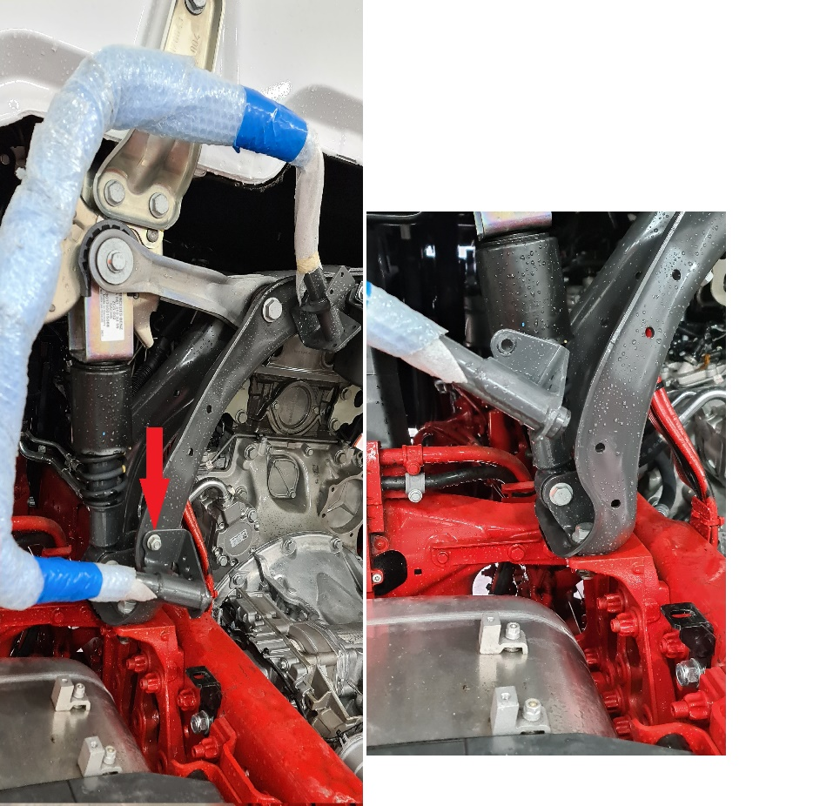
Figure 2

Step 6: Place over the frame and fix both aluminium catwalk!

Step 7: Fix back the factory fitted handle!

Attention!!! Check all fixings!

