

KTZ.MER.C5

MERC ATEGO
DAY CAB OFF ROAD FITTING INSTRUCTION

SPATZ-SHOP
PHONE
NUMBER
01527 60606

- TAKING THE FRONT SECTION (WITH LOGO) INSERT THE REAR FLANGE BETWEEN INNER MUDSHIELD AND OUTER WING (SEE PHOTO POSITION MARKED WITH ‘X’). PULL SPATZ FORWARD UNTILL LOCATED IN CORRECT POSITION.

- DRILL 4 No. 8mm HOLES STARTING FROM POSITION 1. IN FRONT RESESS, MEASURE 25mm IN FROM EDGE OF WING AND 50mm UP FROM BOTTOM OF SPATZ.

- POSITION 4 MEASURE 60mm IN FROM END AND 30mm UP FROM EDGE OF WING.

- POSITION 3 MEASURE 250mm FROM POSITION 4 AND 30mm UP FROM EDGE OF WING.

- POSITION 2 MEASURE 250mm FROM POSITION 3 AND 35mm UP FROM EDGE OF WING.

- USING NUTS AND BOLTS SUPPLIED SECURE FRONT SECTION IN PLACE.

- OFFER UP REAR SECTION MEASURING 40mm IN FROM EDGE OF REAR CHASSIS WING, DRILL 3 No. 8mm HOLES IN POSITIONS 5,6 & 7.

- USING NUTS AND BOLTS SUPPLIED SECURE REAR SECTION.

ANY TRIMMING NECESSARY CAN BE ACHIEVED USING AN ORDINARY HAND SAW OR STANLEY KNIFE (DO NOT LEAVE ANY UNTRIMMED NICKS IN PLASTIC).
INSERT SPATZ BETWEEN INNER MUD WING AND OUTER WING.
4. POSITION 60mm IN 30mm UP
3. POSITION 250mm FROM POS 4, 30mm UP INTO WING.

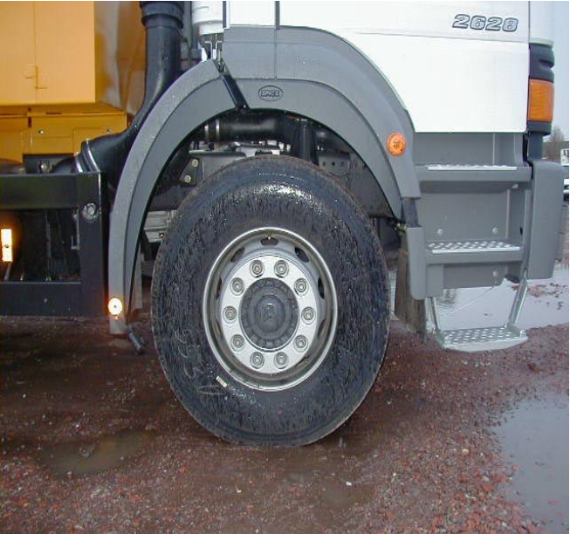
2. POSITION 250mm FROM POS 3, 35mm FROM EDGE OF WING.
1. POSITION 50mm UP FROM BOTTOM 25mm IN FROM EDGE.
5.6.7. POSITIONS 40mm IN FROM EDGE EVENLY SPACED.
X

