

SPATZ SHOP
SALES LINE
01527 60606
KTZ.DAF.05
DAF 85
SLEEPER
FITTING
INSTRUCTIONS

NOTE: CARE SHOULD BE TAKEN IN POSITIONING OF THE HOLES TO AVOID UNNECESSARY DAMAGE TO THE VEHICLE. THE DRILLING OF A 3mm PILOT HOLE IS RECOMMENDED.

- CLAMP CORRECTLY SIDED FRUNTZ TO THE INSIDE OF VEHICLE AS SHOWN BELOW.

- DRILL 4 No 8mm DIAMETER HOLES AS INDICATED APPROX 25mm UP FROM THE BOTTOM OF THE CAB VALANCE.

- USING NUTS AND BOLTS SUPPLIED, SECURE FRUNTZ SECTION INTO POSITION.

- WITH SELF-TAPPER PROVIDED SECURE BOTTOM FRONT SECTION BY STEP (SEE DIAGRAMME).

- OFFER UP REAR SECTION AND DRILL 2 No 8mm DIAMETER HOLES AS INDICATED 25mm IN FROM EDGE OF WING, GETTING POSITION 6 AS LOW AS POSSIBLE.

- USING NUTS AND BOLTS PROVIDED, SECURE REAR SECTION IN PLACE.

ANY TRIMMING REQUIRED CAN BE ACHIEVED USING AN ORDINARY HAND SAW OR STANLEY KNIFE.

1. 8mm HOLE DRILLED 25mm IN FROM BACK OF FRUNTZ.
4. 375mm UP FROM BOTTOM OF SPATZ
SELF-TAPPER SCREW
2 & 3. DRILLED AT TOP OF CURVES.

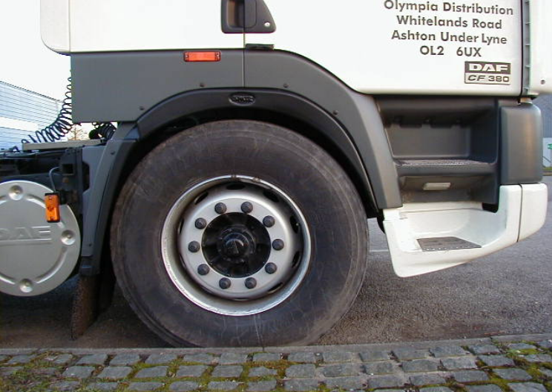
5. 125mm DOWN FROM CURVE IN CHASSIS WING.
6.AS LOW AS POSSIBLE.

