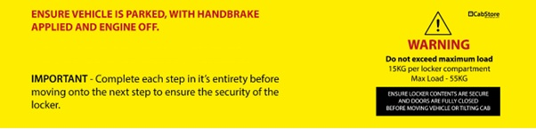
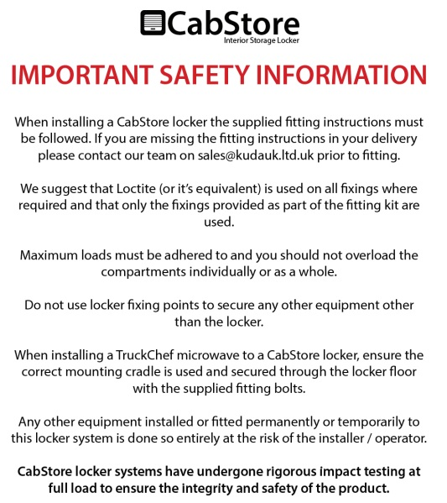

Fitting List
Description | Quantity | Pre-assembled | Fitting kit
M6 x 30mm Flange Head Black (SS) | 11 | 3 | 8
M6 x 30mm Flange Head | 12 |  | 12
M6 x 20mm Set | 6 |  | 6
M6 Nylock | 21(25 for GX) | 3 | 18(22 for GX)
M6 x 12mm Washer | 26(30 for GX) |  | 26(30 for GX)
M6 x 20mm Washer | 9 | 3 | 6
M8 x 20mm Washer black | 1 |  | 1
M8 x 20mm Washer | 6 |  | 6
M8 Hex Nut Insert | 2 |  | 2
M8 Round Nut insert | 4 |  | 4
M8 Hex Nut Cover Black | 1 |  | 1
M8 Nylock | 1 |  | 1
M8 x 25mm Set | 4 |  | 4
M8 x 40mm Set | 2 |  | 2
15mm Spacer | 2 |  | 2
M5 x 15mm Domehead | 12 | 12
Wood Screw, Pan head 4.2(no. 8) x 9mm | 4(6 for GX) |  | 4(6 for GX)
Wood Screw, Pan head 4.2(no. 8) x 13mm | 12(18 for GX) | 8(12 for GX) | 4(6 for GX)
Wood Screw, Pan head 4.2(no. 8) x 25mm | 12(18 for GX) |  | 12(18 for GX)
M8 x 50mm Flat head bolt Black | 2 just for GX |  | 2 just for GX

Tools required:
- Power Drill
- Drill bit 3mm, 6mm, 11mm
- Nut Insert Tool M8
- Socket/Spanner 10mm, 13mm
- Allan key H4
- Torx key T45, T20
- PH2, PZ2 driver bit/screwdriver
- Marker pen

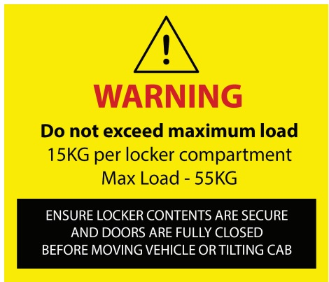
The fitting instructions can slightly varies depending on the tractor’s unit specifications and generation!

Step 1 – Remove second bunk (if present), the hook and the factory fitted side plastic panel, marked with red arrows in Figure 1. Repeat step for opposite side! You may also wish to mask the interior side plastic panels to protect them during the fitment process!

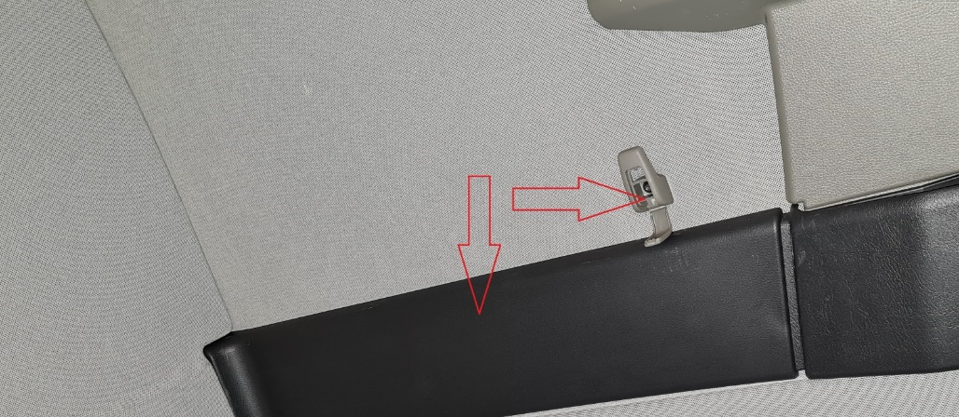
Figure 1

Step 2 – Instal the Hex nut insert in the factory hex shape marked with yellow in “Figure 2”. Repeat step for opposite side!

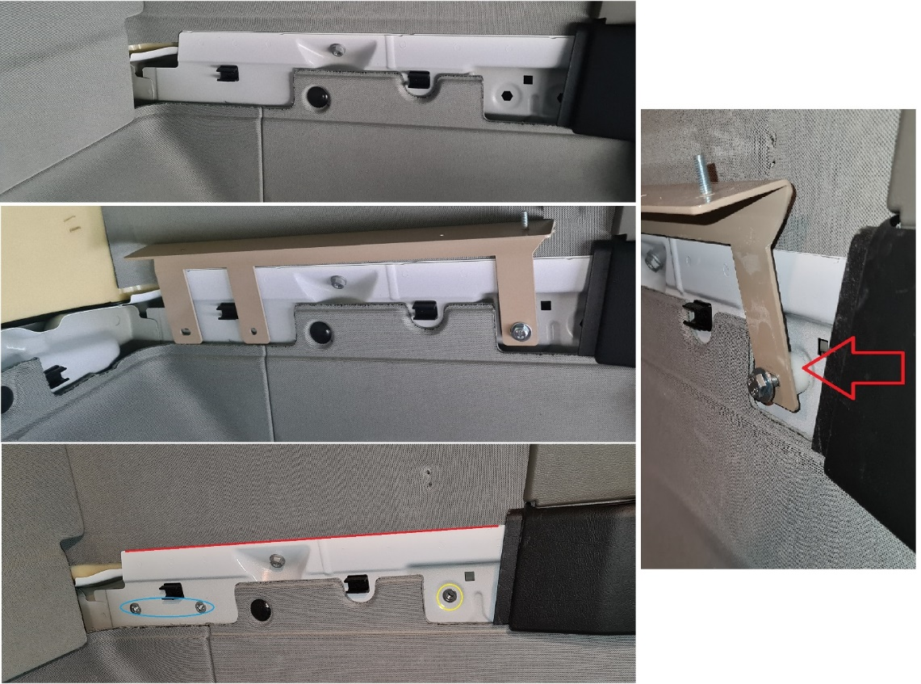
Figure 2
Step 3 – Using 15mm spacer, M8 x 40mm set, fit and hand tight just front fixing of the Side floor bracket as in “Figure 2”. Repeat step for opposite side!
Step 4 – Holding the Side floor bracket parallel with the edge of the cab’s metal, marked with red line from “Figure 2”, mark, drill 11mm hole and fit M8 round nut inserts for the rear fixings of the bracket marked with blue in “Figure 2”. Repeat step for opposite side!

Step 5 – Loosely fit the bracket through rear fixings, as in “Figure 3”, using:
- M8 x 25mm sets
- M8 x 20mm washers
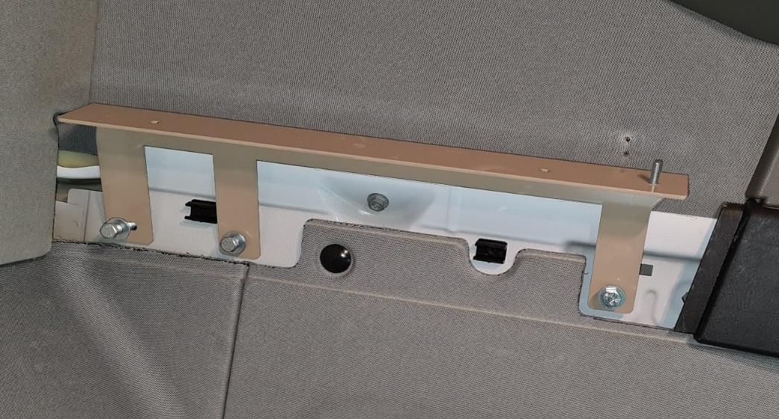
Figure 3
Step 6 – Remove rear top wall upholstery panel, in the middle of rear wall factory roof fixing, fit the “L” bracket, using factory nut to secure, as in “Figure 4”
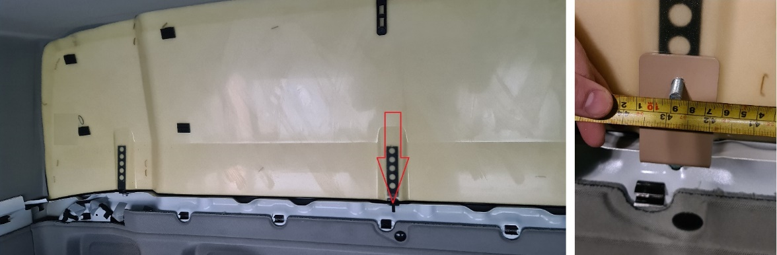
Figure 4
Step 7 – Refit the factory rear upholstery panel, drilling it to allow the stud of the “L” bracket fitted at “Step 5” to come through, see “Figure 5”.
Figure 5
Step 8 – Fit the Side face bracket on top of Side floor bracket, hand tighten to allow the Side face bracket to slide! See “Figure 6”! Repeat step for opposite side!
Using:
- M6 Nylocks
- M6 x 20mm Washers
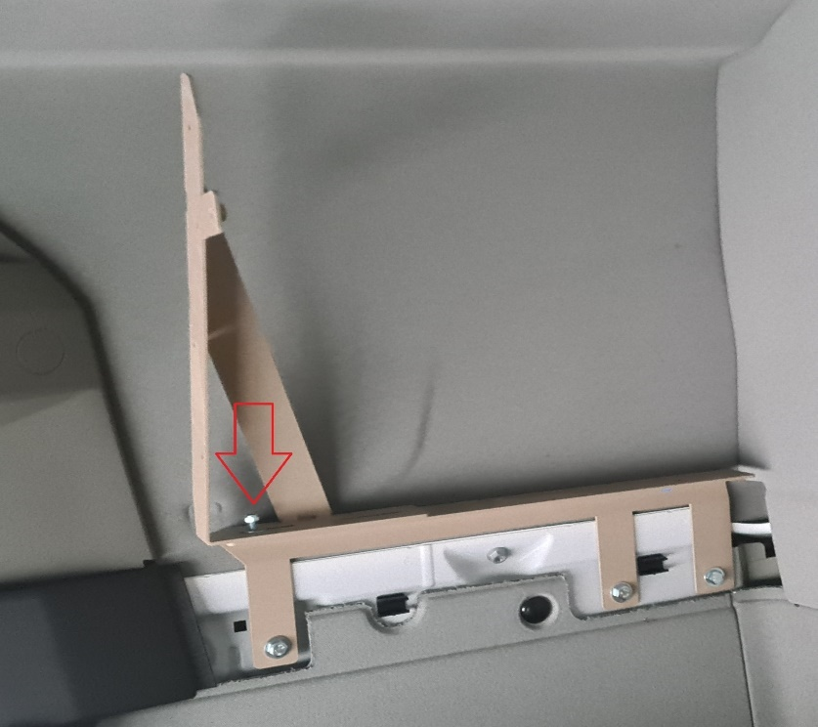
Figure 6
Attention – For the next step we suggest two people!
Step 9 – Fit the floor, sliding the rear stud, fitted at “Step 6 and 7”, through the slot of the L bar preassembled to the floor, secure the back off the floor using M8 Nylock and M8 x 20mm Washer Black, and under the Side floor bracket, fitted at “Step 5”! See “Figure 7”! Secure the sides of the floor through the Side floor brackets holes using:
- M6 x 30mm Flange Head Black (SS)
- M6 x 20mm washer
- M6 Nylock
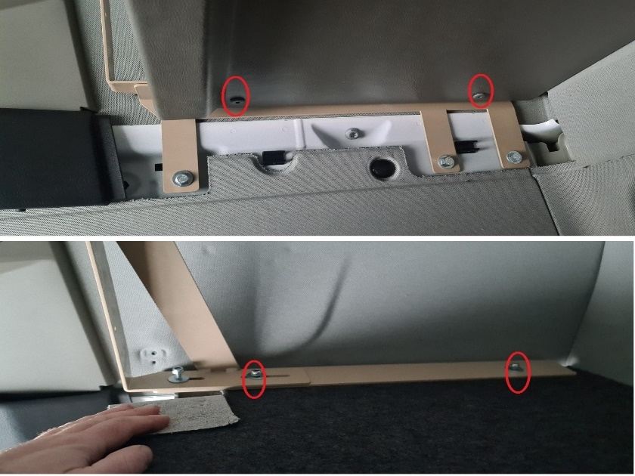
Figure 7

Attention – For the next step we suggest two people!
Step 10 – Fit the fascia panel and secure it to Side face brackets, fitted at “Step 8”, using M6 x 30mm Flange Head Black (SS), see “Figure 8”. Secure it to the floor panel, see “Figure 9”, using:
- M6 x 20mm Set
- M6 x 12mm Washer
- M6 Nylock
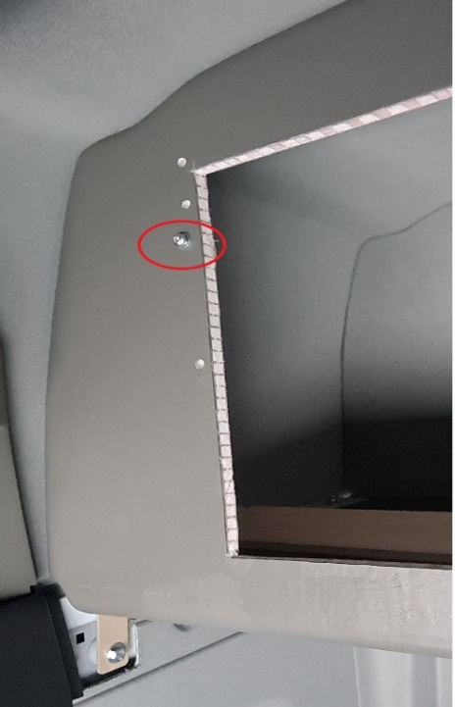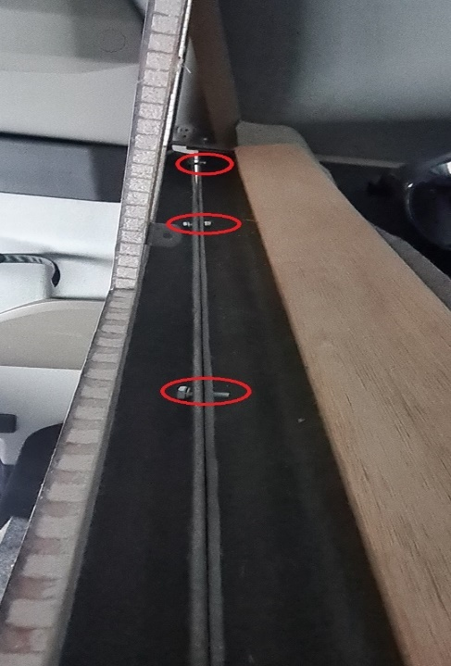
Figure 8 Figure 9
Step 11 - Check for the fascia side bracket sit flat to inside of fascia panel, sliding on top of side floor bracket, tight all fixings from previous steps!

Step 12 – Remove the factory fitted roof brackets, see “Figure 10”.
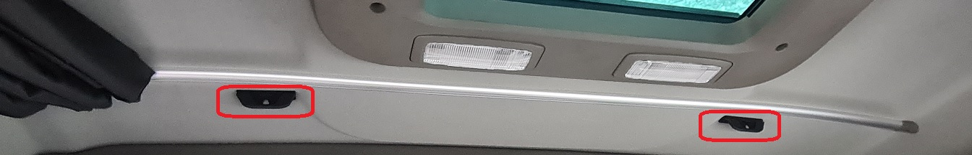
Figure 10

Step 12 – Fit the supplied roof bracket using factory fixings removed at “Step 12”, see “Figure 11”.
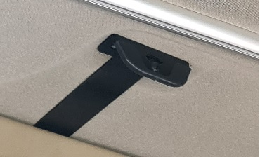
Figure 11

Step 13 – From inside the locker drill the fascia panel through the roof bracket using a small drill bit(3mm) to not damage the thread, must be minimum 15mm away from the top aperture of the door! From outside the locker enlarge the hole to 7mm and secure the fascia to the roof bracket using M6 x 30mm Flange Head Black (SS). See “Figure 12”!
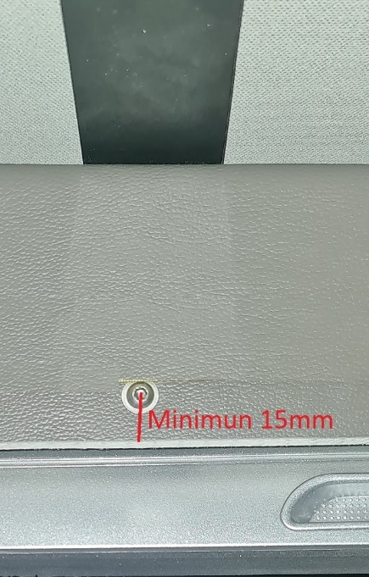
Figure 12

Step 14 – Fit all doors assembly through the predrilled holes, using M6 x 30mm flange head, see “Figure 13”.
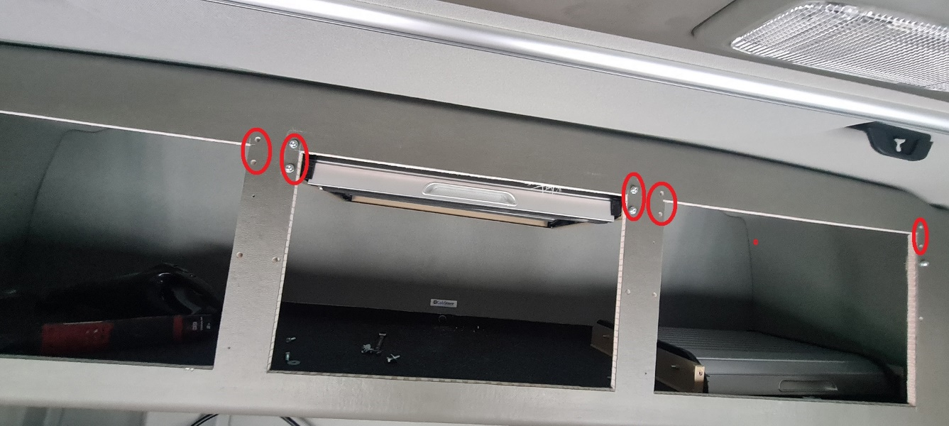
Figure 13
Step 15 – From the side door aperture, insert dividers between door assembly against the L brackets from inside the locker face, then secure through the L brackets from centre door aperture secure the divider using 13mm wood screw (see “Figure 14”), then into the floor use 9mm wood screw (see “Figure 15”).
Do not over-tighten!
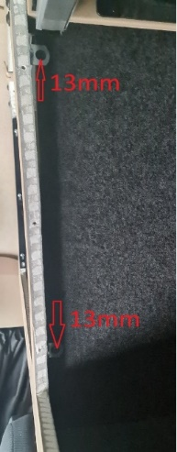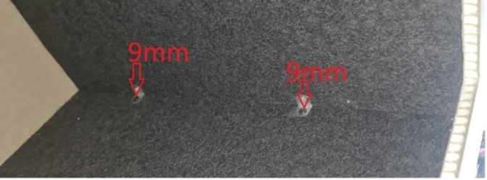
Figure 14 Figure 15

Step 16 – Install the side runners by sliding upwards into the slots of the door assembly, drill 3mm holes and secure with 25mm wood screw, see “Figure 16”.
Do not over-tighten!
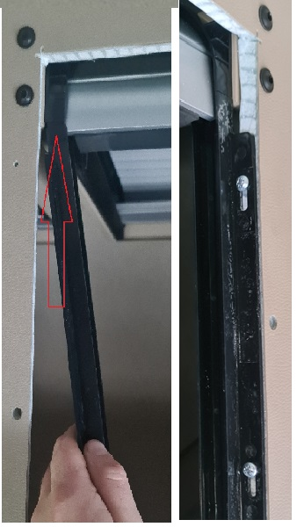
Figure 16
Step 17 – Instal the door surrounds by pushing the surround studs through the predrilled holes in the locker front, secure it using M6 washer and M6 nylock, see “Figure 17”.
Do not over-tighten, tight until the door surround touches the locker face!
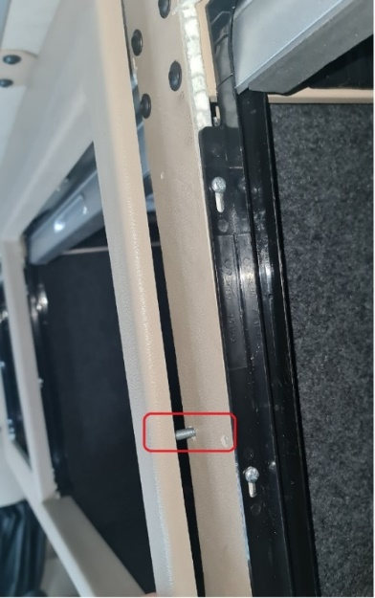
Figure 17

ENSURE ALL FIXINGS ARE SECURE AND CHECKED PRIOR TO USING VEHICLE!

Step 18 – Refit the factory side panels removed at “Step 1”.
Step 19 – Fit the upholstery cut out for bunk brackets (if needed) covers, using M8 x 50mm Flat head bolt Black. Do not over tight!

Attention: Use Locktite (or equivalent) on all fixings where required!

