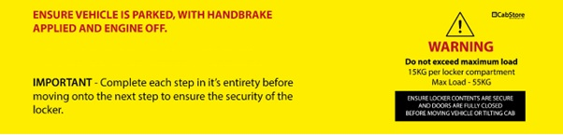
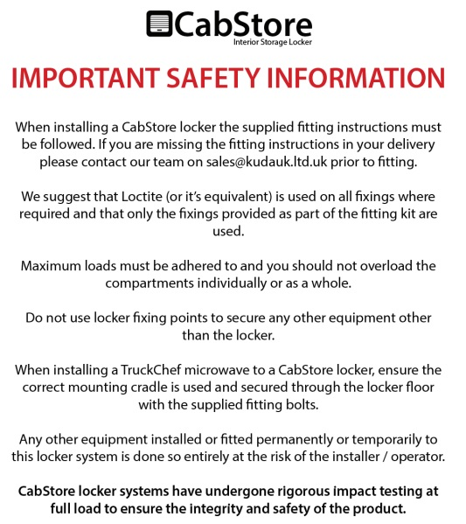

Fitting List
Description | Quantity | Pre-assembled | Fitting kit
M6 x 30mm Flange Head (SS) |  |  | 4
M6 x 30mm Flange Head |  |  | 12
M6 x 20mm Set |  |  | 7
M6 Nylock |  |  | 19
M6 x 12mm Washer |  |  | 24
M6 x 20mm Washer |  |  | 2+8(spacers)
M8 x 30mm Washer Black |  |  | 4
M8 Hex Nut Cover Black |  |  | 4
M8 Nylock |  |  | 4
M8 x 60mm Set |  |  | 4
M8 x 40mm flat head Black S/S |  |  | 4
M8 x 25mm carriage bolts |  |  | 4
M5 x 15mm domehead |  | 12
Wood Screw, Pan head 4.2(no. 8) x 9mm |  |  | 16
Wood Screw, Pan head 4.2(no. 8) x 13mm |  | 21 | 16
Wood Screw, Pan head 4.2(no. 8) x 25mm |  |  | 18

Tools required:
- Power Drill
- Drill bit 3mm, 6mm
- Socket/Spanner 10mm, 13mm
- Allan key H4, H5
- Torx key T45
- PH2, PZ2 driver bit/screwdriver
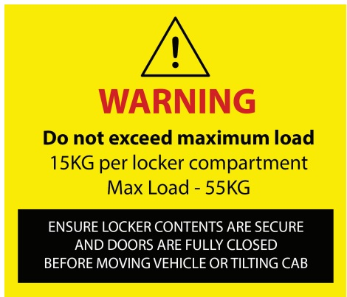
The fitting instructions can slightly varies depending on the tractor’s unit specifications and generation!

Step 1 – Remove top bunk! You may also wish to mask the interior side plastic panels to protect them during the fitment process, see red marks in “Figure 1”!
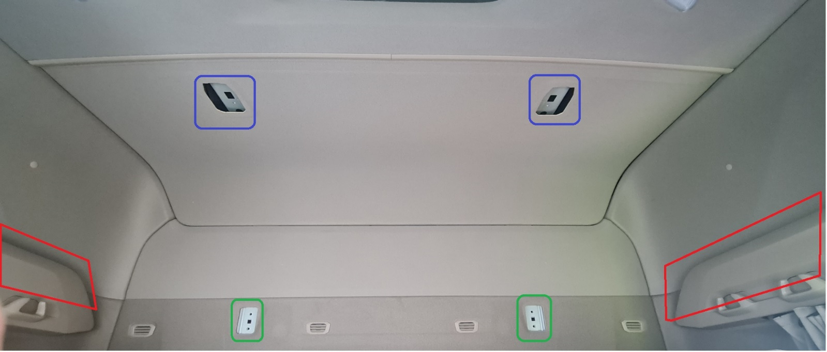
Figure 1

Step 2 – Instal the rear brackets, with the M8 x 25mm carriage bolts fit through the rectangular cuts of the rear bracket, from the back to the front of the cab! Secure it using M8 x 40mm flange Bolts Black! See green marks in “Figure 1” and “Figure 2” for guidance!
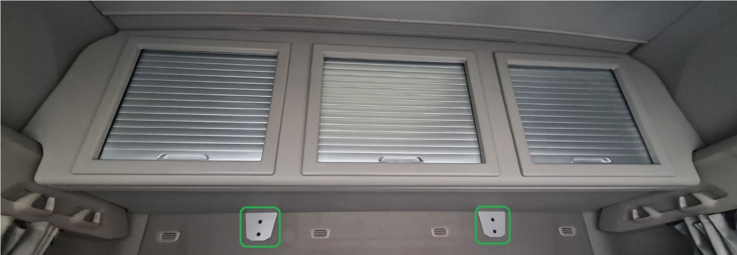
Figure 2

Attention – For the next step we suggest two people!
Step 3 – Careful to not damage the cab interior, place the floor on position, sliding the rear stud, fitted at “Step 2”, through the holes in the back return of the floor, secure the back off the floor using M8 Nylock and M8 x 25mm Washer Black!

Attention – For the next step we suggest two people!
Step 4 – Careful to not damage the cab interior, place the fascia panel on position and secure it to the floor using M6 x 20mm sets, M6 x 12mm washers and M6 Nylocks. See “Figure 3”.
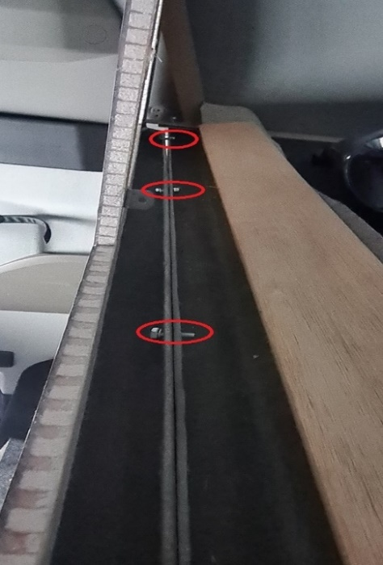
Figure 3
Attention – For the next step we suggest two people!
Step 5 – Holding the fascia panel to not damage the cab’s interior, inside the locker instal the top brackets, secure them using M8 x 60 Sets, then secure the fascia panel to the top bracket using M6 x 30mm flange head (SS)!
Step 6 – Fit all doors assembly through the predrilled holes, using M6 x 30mm flange head, see “Figure 4”.
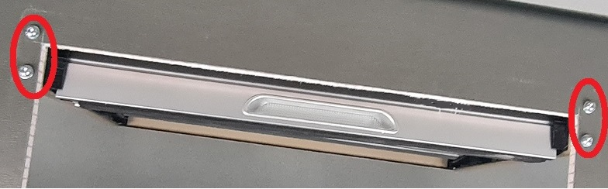
Figure 4
Step 7 – Instal the dividers against the preinstalled L brackets, then secure through the L brackets using 13mm wood screw (see “Figure 5”), then into the floor use 9mm wood screw (see “Figure 6”).
Do not over-tighten!
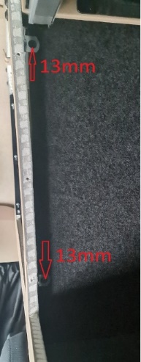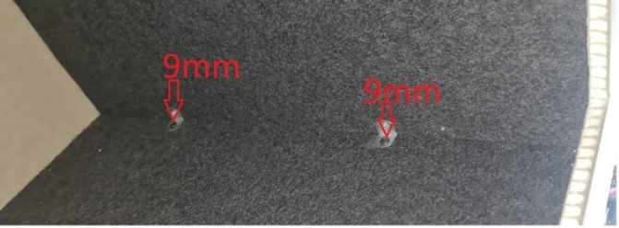
Figure 5 Figure 6

Step 8 – Install the side runners by sliding upwards into the slots of the door assembly, drill 3mm holes and secure with 25mm wood screw, see “Figure 7”.
Do not over-tighten!
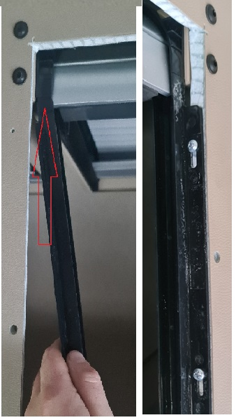
Figure 7
Step 9 – Instal the floor bracket(bigger fold), from the outside carriage bolt of the rear fixing bracket, crossing the floor, then drill 6mm hole the fascia panel through the other end of the floor bracket(smaller fold) and secure using M6 x 30mm flange head SS, M6 x 20mm washer and M6 nylock, if required use M6 x 20mm washers as spacers! Repeat step for opposite side!

Step 10 – Instal the door surrounds by pushing the surround studs through the predrilled holes in the locker front, secure it using M6 washer and M6 nylock, see “Figure 9”.
Do not over-tighten, tight until the door surround touches the locker face!
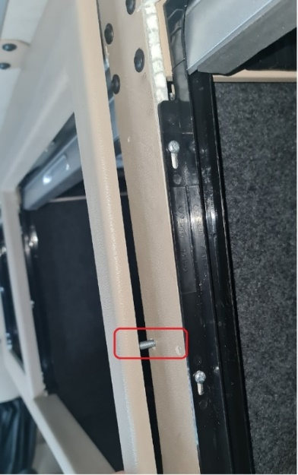
Figure 9

ENSURE ALL FIXINGS ARE SECURE AND CHECKED PRIOR TO USING VEHICLE!

Attention: Use Locktite (or equivalent) on all fixings where required!

