Fitting kit
Description | Quantity
M8 x 30mm Set | 6
M8 x 30mm Washer | 30
M8 Nylock | 16
500mm Safety Strap | 2
30mm x 30mm Foam 300mm strip | 2
Alcohol wipes | 2

Brackets

Description | Part number | Quantity
DAF XG+ Bracket 3 | W 067-426-089-019 | 1
DAF XG+ Bracket 4 | W 067-426-089-020 | 1

ENSURE VEHICLE IS SECURE PARKED, WITH HANDBRAKE APPLIED AND ENGINE OFF!

Step 1 – Disconnect the power supply and remove factory fitted indicator light from behind of front wheel, see “Figure 1”. Repeat step for opposite side!

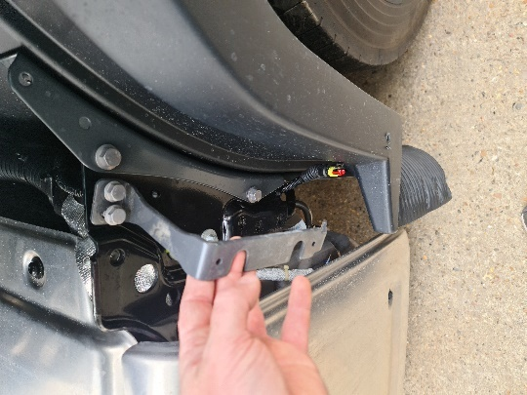
Figure 1

Step 2 – Fix the factory fitted indicator light on the supplied fibreglass Side-Skirt through the predrilled holes, as in “Figure 2”. Repeat step for opposite side!

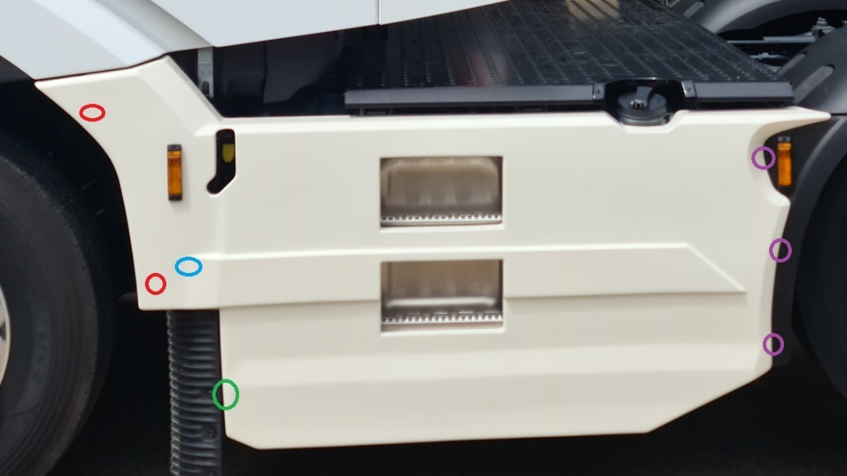
Figure 2
Step 3 – Fit the safety strap to in one of the factory fixing of the light bracket, removed at “Step 1”. Repeat step for opposite side!

Step 4 – Just for near side - clean/degrease the tank strap and stick the foam strip on the bottom of the tank strap, see “Figure 3”.
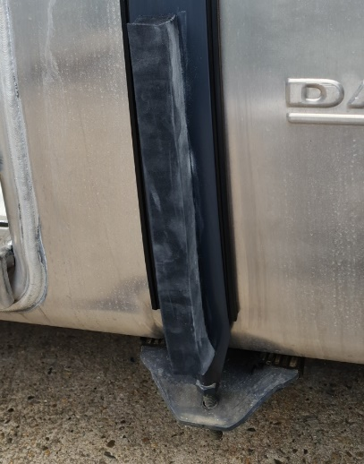
Figure 3

Step 5 – Place the SideSkirt on position, see “Figure 2”, mark and drill where the fixings will go through rear plastic wings purple marks, and the bonded studs, red marks into the front plastic mudwing for front top and middle fixing, see “Figure 4” red marks for approximate location. Repeat step for opposite side!
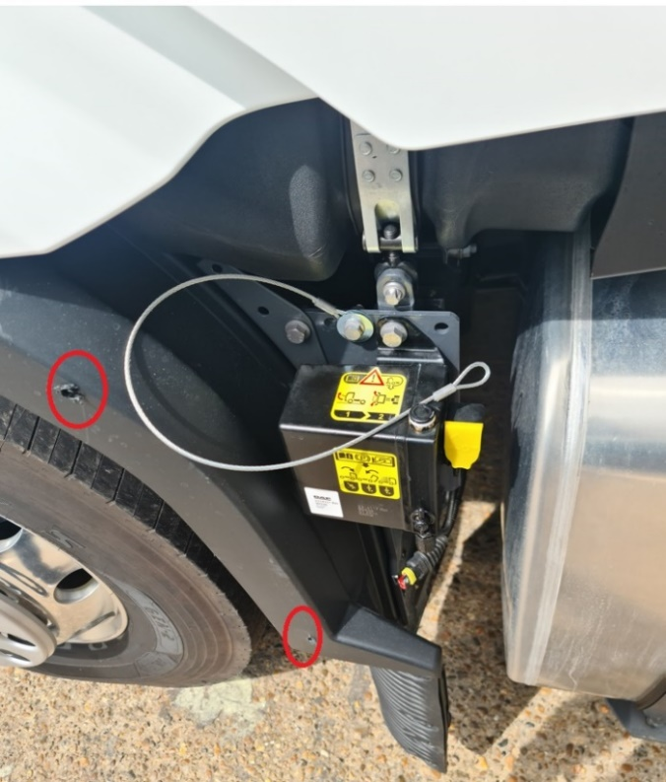
Figure 4

Step 6 – Fit the handed “L” bracket in the factory fixing marked in “Figure 5”, for front bottom fixing. Repeat step for opposite side!
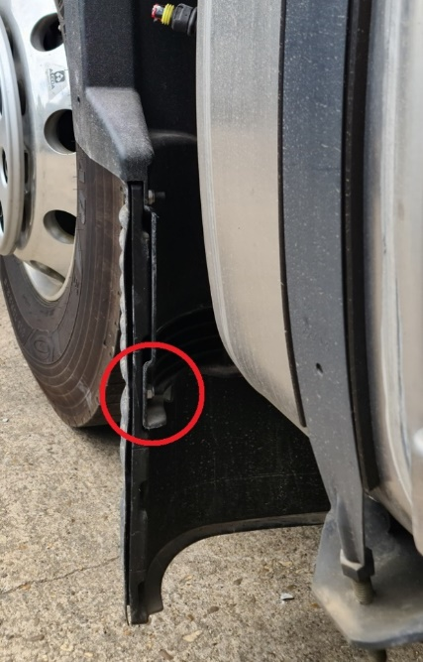
Figure 5
Step 7 – Attach the safety strap to the side skirt and connect the factory light, see “Figure 6” blue mark. Repeat step for opposite side!

Step 8 – Place the side skirt on position and secure it with M8 fixings! Repeat step for opposite side!
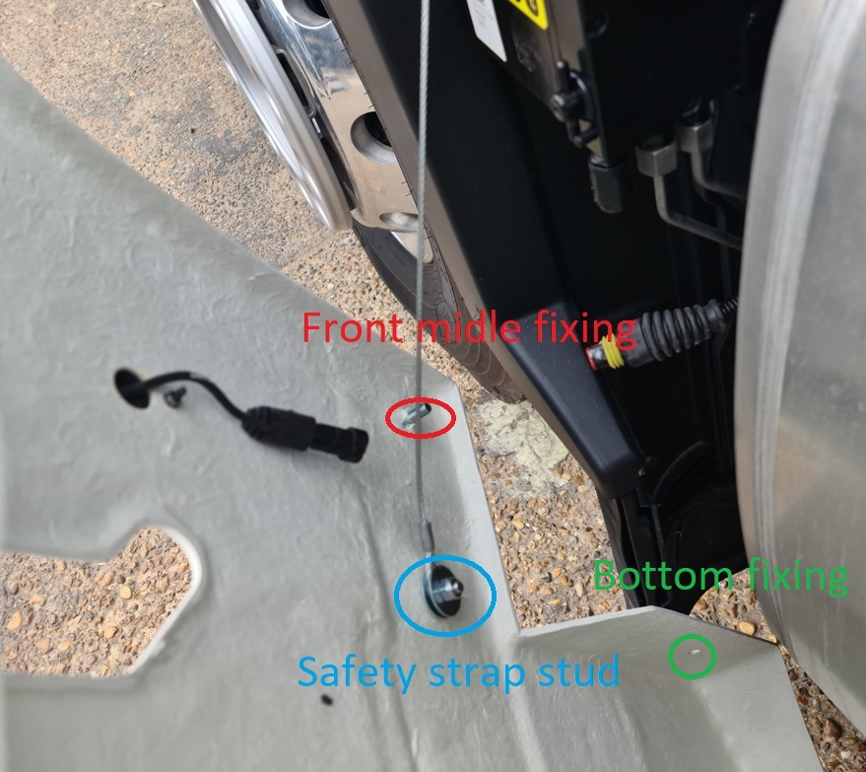

Attention!!! Tight all the fixings!!!!

